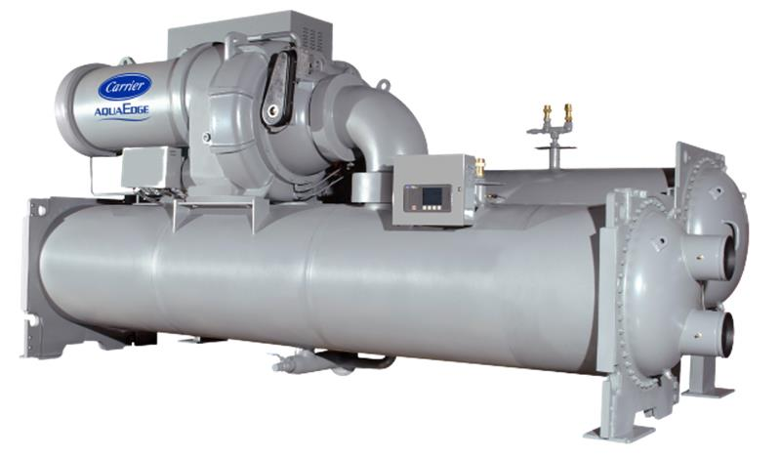

Chiller background
Chiller details | Information
Chiller Number | $ChillerSN
Location | $LocationName
City | $LocationCity
Year of Manufacturing (Age) | $Year_Age
Model Number | $ModelNum
Chiller Run Hours | $runhrs
Report Duration | $StartDate to $EndDate
Chiller Capacity (RT) | $DesignRT
Rated Chilled Power (kW) | $DesignChillerPower
Design Leaving Chilled Water Temperature ($T_Unit) | $Design_LCW
Design Entering Condenser Water Temperature ($T_Unit) | $Design_ECDW
Report Release Date | $Today_date

Summary
 | As part of Carrier's connected service program, our command center experts continuously monitor the performance and health of the chiller and its major components.
 | The chiller with serial number $ChillerSN underwent a chiller retrofit analytics program considering its age and run hours exceeding 20 years and 70,000, respectively. Further analysis was conducted using real-time data from $StartDate to $EndDate.
 | The chiller's design full load efficiency is $Design_Efficiency kW/RT at design chilled water & condenser water temperature of $Design_LCW$T_Unit and $Design_ECDW$T_Unit respectively, while the computed chiller $performance_str is $maxium_data_efficiency $performance_unit at average chilled water & condenser water temperature of $maxium_data_mean_LCW & $maxium_data_mean_ECDW respectively during the analysis period.
 | These are initial analytic and findings of a chiller performance from telemetry data within a specified period. Further investigation and energy assessment on chiller plant level are recommended to understand existing chiller plant baseline performance. Carrier offers in-house engineering tools to assist our customers in developing new solution with optimized configuration and operation.

Chiller Performance Analysis
$effi_PLC_ECDW

Comments
- The chiller $performance_unit is steadily $trend compared to the previous year, indicating an increase in energy consumption per unit of cooling output.
- This trend indicates a potential decline in efficiency, emphasizing the need for further investigation to address and rectify underlying issues.
$19XRV_installed_VFD
- The chiller efficiency(kW/RT) is similar compared to the previous year. $19XRV_installed_VFD

$Chiller efficiency vs %RLA vs Runhrs

Comments
- This plot illustrates various part-load efficiencies based on specific criteria:
  - The chiller operates at full load for more than 80% of the time: $full_load_80
  - The chiller frequently operates at less than 60% of its RLA for most of the time (more than 80% of the time): $low_load_80
  - The chiller is installed with VFD: No

$Chiller efficiency vs Cooling load vs Runhrs

Comments
- This plot illustrates various part-load efficiencies at different Cooling Loads:
  - Most of the time ($MostRunhrsOFTon%) chiller operates from $Ton_range RT.
Chiller Alarm Analysis

$alarm_count

Comments
- The chiller device has total of $total_alarms alarms during this analysis timeframe.
- There have been $exceed_15 instances of chiller device alarms exceeding 15 in the last 2 months.

Chiller Water Temperature Analysis
$LCW_SP

Comments
- The leaving chilled water temperature meets $setpoint_meet%, the set point.

$Entering_Condenser_Water

占位符
Comments
- The average entering condenser water temperature falls within the range of $min_ECDW$T_Unit to $max_ECDW$T_Unit.

Chiller Data 2022 (Average)
Year 2022 | Jan | Feb | Mar | Apr | May | Jun | Jul | Aug | Sep | Oct | Nov | Dec
Leaving Chilled water temperature, °F
Chiller power consumption, kW
Chiller efficiency, kW/RT
Cooling load, RT
Entering Condenser water temperature, °F
Chiller energy consumption, kWh

$Temperature_Ton_2022

$Effi_EnergyConsumption_2022

占位符
占位
占位符
占位符
占位符
占位符
占位符

$Ton_power_2022

Chiller Data 2023 (Average)
Year 2023 | Jan | Feb | Mar | Apr | May | Jun | Jul | Aug | Sep | Oct | Nov | Dec
Leaving Chilled water temperature, °F
Chiller power consumption, kW
Chiller efficiency, kW/RT
Cooling load, RT
Entering Condenser water temperature °F
Chiller energy consumption, kWh

占位符
占位符
占位符
占位符
$Temperature_Ton_2023

$Effi_EnergyConsumption_2023

占位符
占位符
占位符
占位符
占位符
占位符
占位符
占位符

$Ton_power_2023

Chiller Data 2024 (Average)
Year 2024 | Jan | Feb | Mar | Apr | May | Jun | Jul | Aug | Sep | Oct | Nov | Dec
Leaving Chilled water temperature, °F
Chiller power consumption, kW
Chiller efficiency, kW/RT
Cooling load, RT
Entering Condenser water temperature °F
Chiller energy consumption, kWh

符
占位符
占位符
占位符
占位符

$Temperature_Ton_2024

$Effi_EnergyConsumption_2024

占位符
占位符
占位符
占位符
占位符
占位符
占位符

$Ton_power_2024

